

**Type Facility or Provider Name Here.**

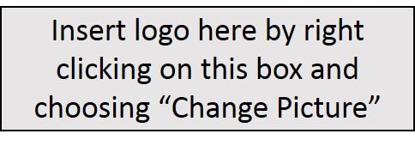

Your health is important to us. As your dental provider, I promise to provide you with the best care possible. I am dedicated to avoid prescribing antibiotics when they are likely to do more harm than good.

is committed to being antibiotics aware!

You have a role to play in antibiotic stewardship, too!

Learn more by visiting:  
[www.cdc.com/antibiotic-use](http://www.cdc.com/antibiotic-use)